Data Analyst Challenge

Part 1

We have multiple apps emitting different kinds of events, such as when a push notification has

been received, when a certain screen was viewed, or the app has been updated. We also get

an event called “user_engagement” for each session of use, with the time the user was active in

the app.

We would like to be able to plot the number of active users per day. Our analytics database is

an SQL database, so the data from the event should be loaded in the following table:

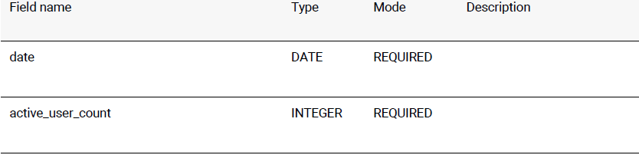

Using the data in the attached json file, create a script to load the data from the events into the

table above. You can use python, or any language you feel familiar with. Please provide

instructions on how to run the script.

We expect the result as a github repository. Please leave the commit history in.